Frequency Tables-Answers
Key Stage 3: 2003 Paper2 Level 3-5
1.
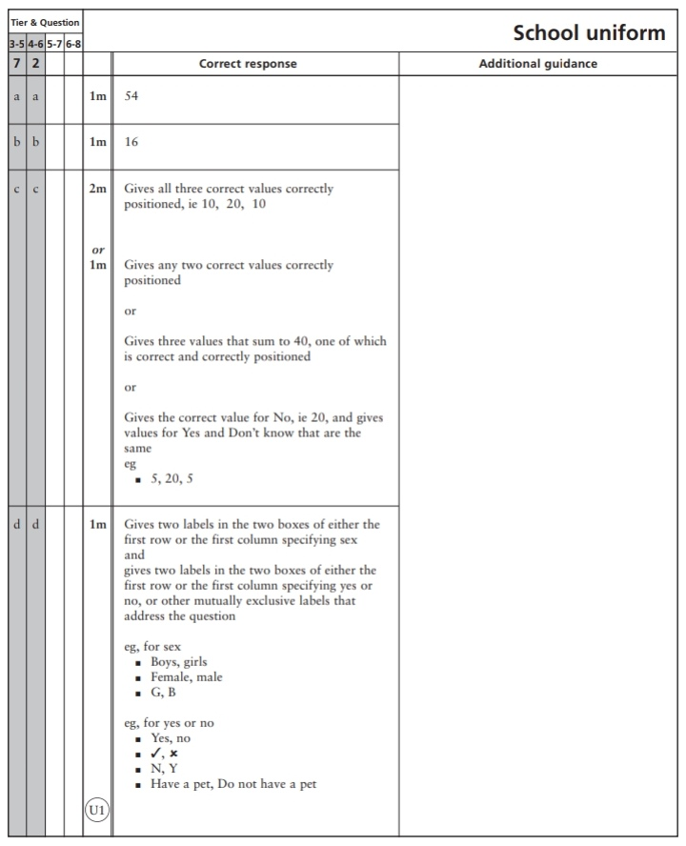
2.
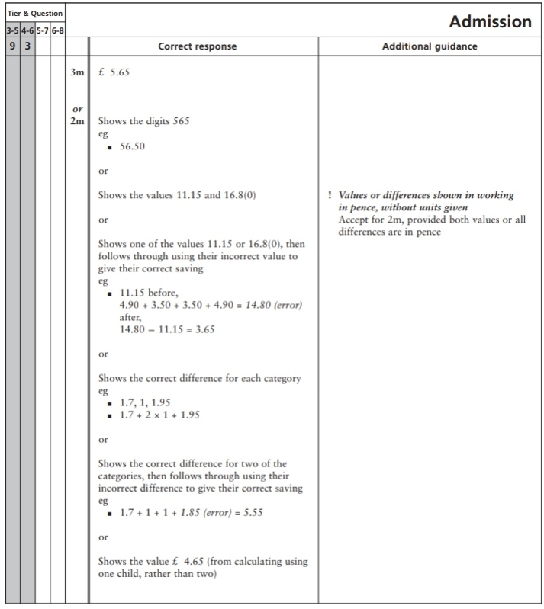
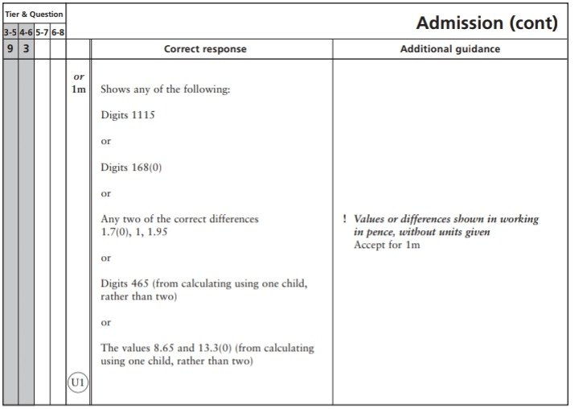
Key Stage 3: 2003 Paper 2 Level 4-6
3.
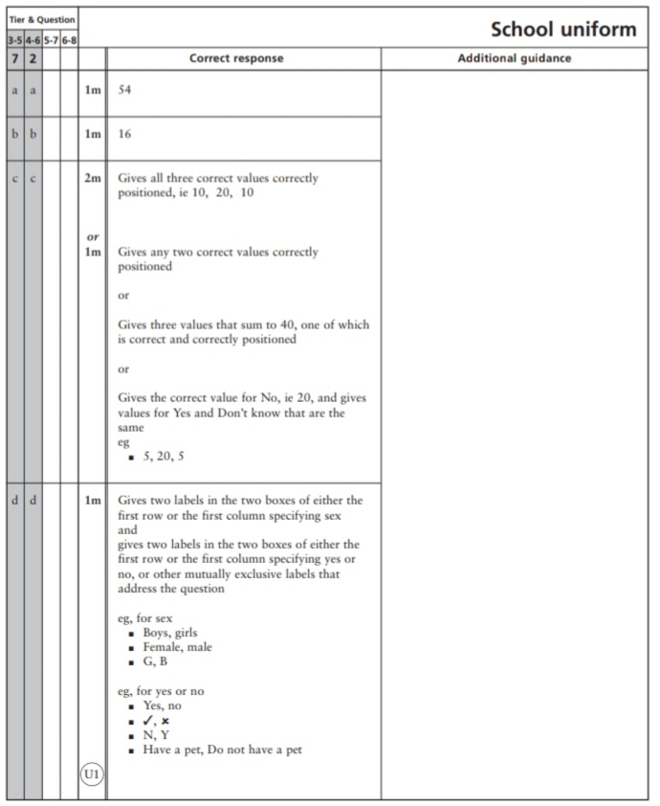
4.
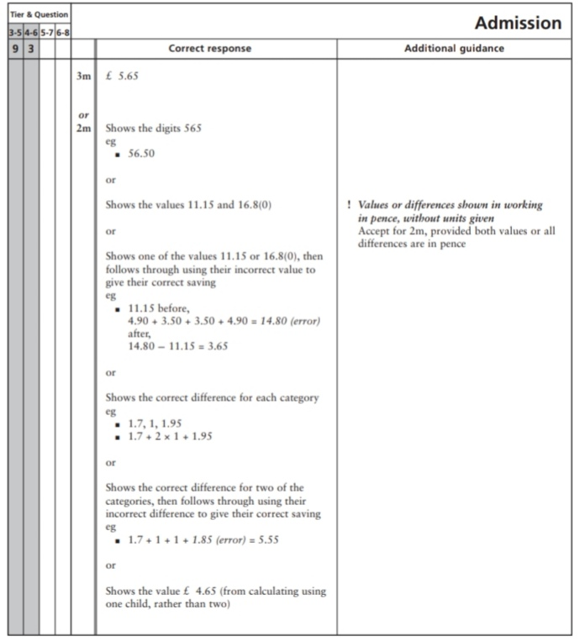
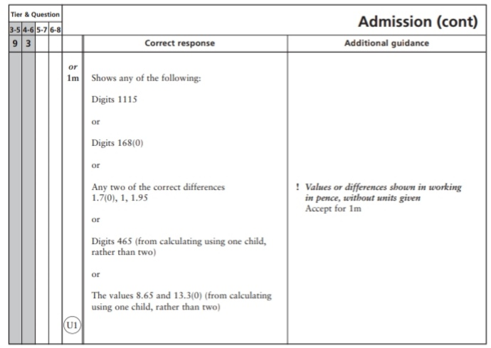Key Stage 3: 2005 Paper 1 Level 3-5
5.
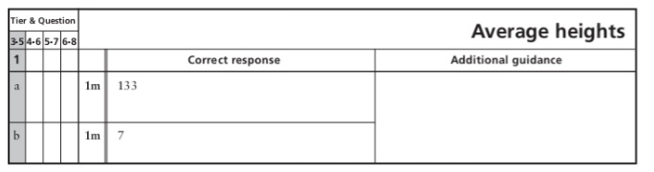
Key Stage 3: 2006 Paper 2 Level 3-5
6.
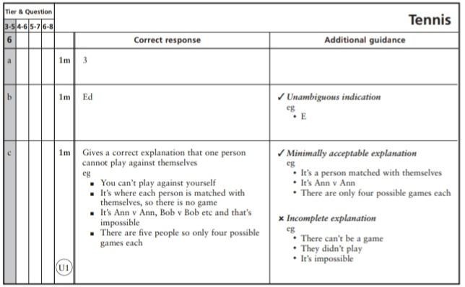
Key Stage 3: 2009 Paper 2 Level 4-6
7.
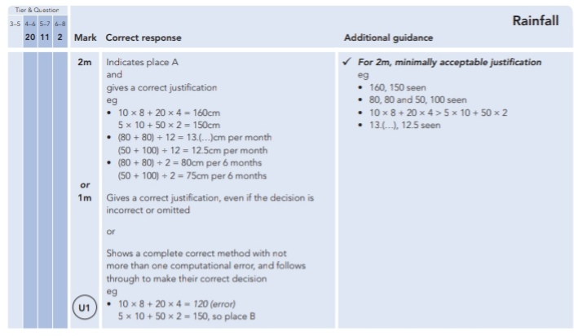
Key Stage 3: 2010 Paper 1 Level 3-5
8.
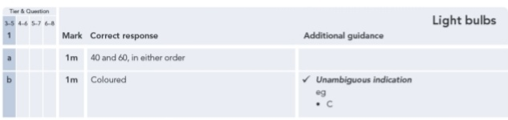
Key Stage 3: 2010 Paper 2 Level 3-5
9.
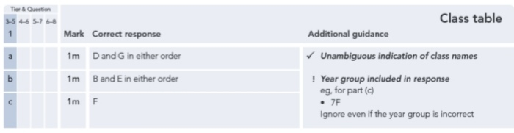
10.
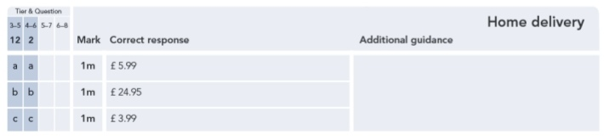
11.
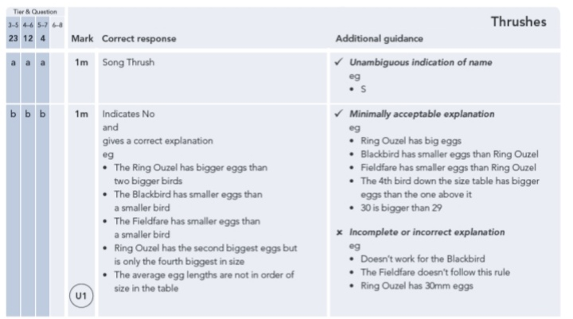
Key Stage 3: 2010 Paper 2 Level 4-6
12.
13.
Key Stage 3: 2011 Paper 1 Level 4-6
14.
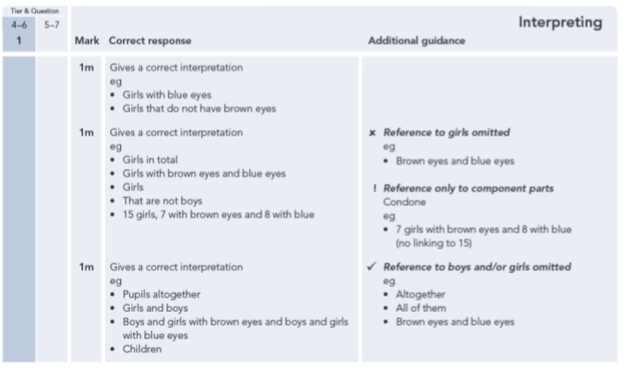
15.
